

**Chalao**

**Software Project -1**

## Submitted by

|  |  |
| --- | --- |
| **Name** | **ID** |
| **Fahim, Hasan Shahria** | **16-32025-2** |
| **Mahmud, Iftekhar** | **16-32028-2** |
| **Mahtab, Tanvir** | **16-32044-2** |
| **Irfan, Iraz** | **16-32084-2** |

### Under the Supervision of

**Mohaimen-Bin-Noor Lecturer**

**Department of Computer Science American International University – Bangladesh**

**Date of Submission: May, 2019**

**DECLARATION**

This is to certify that this project is our original work. No part of this work has been submitted elsewhere partially or fully for the award of any other degree or diploma. Any material reported in this project has been properly acknowledged.

|  |  |  |
| --- | --- | --- |
| **FAHIM, HASAN SHAHRIA**  16-32025-2  CSSE |  | **MAHMUD, IFTEKHAR**  16-32028-2  CSSE |
| **MAHTAB, TANVIR**  16-32044-2  CSSE |  | **Irfan, Iraz**  16-32084-2  SE |

# APPROVAL

The project titled “**Chalao**” has been submitted to the following respected members of the board of examiners of the Department of Computer Science, American International University – Bangladesh [AIUB] in partial fulfilment of the requirements for the degree of Bachelor of Science in Computer Science and Software Engineering / Bachelor of Science in Software Engineering on May 8, 2019 and has been accepted as satisfactory.

|  |  |  |
| --- | --- | --- |
| **MOHAIMEN-BIN-NOOR**  Assistant Professor  Department of Computer Science Faculty of Science & IT  AIUB |  | **MD. AL-AMIN**  Lecturer  Department of Computer Science Faculty of Science & IT  AIUB |
| **DR. M. M. MAHBUBUL SYEED**  Associate Professor and Head [UG Program] Department of Computer Science  Faculty of Science & IT AIUB |  | **PROF. DR. TAFAZZAL HOSSAIN**  Pro-Vice Chancellor and Dean  Faculty of Science & IT AIUB |
| **DR. CARMEN Z. LAMAGNA**  Vice Chancellor AIUB | | |

## ACKNOWLEDGEMENT

This project is the result of our cordial effort and our supervisor’s initiative and constant motivation. But first of all, we would like to be grateful to the Almighty ALLAH, who gives us the effort to work on this project. Special thanks goes to our honorable supervisor Mohaimen-Bin-Noor, Assistant Professor, American International University – Bangladesh [AIUB]. His excellent supervision and constant support makes this project possible. We also want to thank our Vice Chancellor Dr. Carmen Z. Lamagna, our Dean Prof. Dr. Tafazzal Hossain, our Associate Dean- In-Charge, Mr. Mashiour Rahman, and our Head of Department Dr. Dip Nandi for their constant motivation and support.

## TABLE OF CONTENT

|  |  |  |
| --- | --- | --- |
|  | Project Summary………………………………………………………………... | 8 |
| 1 | INTRODUCTION ……………………………………………………………... | 9 |
| 1.1 | Purpose…………………………………………………………………………. | 9 |
| 1.2 | Background To The Problems …………………………………………………. | 9 |
| 1.3 | Project Scope …………………………………………………………………… | 9 |
| 1.4 | Intended Audience And Reading Suggestions …………………………………. | 10 |
| 2 | EXISTING APPLICATION / SYSTEM STUDY ……………………………... | 11 |
| 2.1 | List Of Domestic Applications / Systems ……………………………………… | 11 |
| 2.2 | List Of International Applications / Systems …………………………………... | 11 |
| 2.3 | Features In Existing Applications / Systems …………………………………… | 11 |
| 2.4 | Features In Domestic Applications …………………………………………….. | 13 |
| 2.5 | Features In International Applications …………………………………………. | 14 |
| 3 | REQUIREMENT SPECIFICATIONS ………………………………………… | 16 |
| 3.1 | Application Perspective ………………………………………………………... | 16 |
| 3.2 | Application Features …………………………………………………………… | 16 |
| 3.3 | User Characteristics ……………………………………………………………. | 17 |
| 3.4 | Requirements For End User ……………………………………………………. | 17 |
| 3.4.1 | Requirements For Unregistered Users …………………………………………. | 17 |
| 3.4.2 | Requirements For Registered Users (Foodies) ………………………………… | 18 |
| 3.4.3 | Requirements For Restaurant Owners …………………………………………. | 18 |
| 3.4.4 | Requirements For Admins ……………………………………………………... | 19 |
| 3.5 | Operating Environment ………………………………………………………… | 19 |
| 3.6 | Design And Implementation Constraints ………………………………………. | 20 |
| 3.7 | User Documentation ……………………………………………………………. | 20 |
| 3.8 | Assumptions And Dependencies ……………………………………………...... | 21 |
| 4 | DESIGN SPECIFICATIONS …………………………………………………. | 22 |
| 4.1 | User Scenario …………………………………………………………………... | 22 |
| 4.2 | UML Diagrams ………………………………………………………………… | 24 |
| 4.2.1 | Use Case Diagrams ……………………………………………………………... | 24 |
| 4.2.2 | Activity Diagrams ……………………………………………………………… | 25 |
| 4.2.3 | Entity Relation Diagram ………………………………………………………... | 28 |
| 4.3 | Data Dictionary ………………………………………………………………… | 29 |
| 4.4 | User Interface Design …………………………………………………………... | 32 |
| 5 | FEATURES IMPLEMENTATIONS …………………………………………... | 36 |
| 5.1 | Sign Up ………………………………………………………………………… | 36 |
| 5.2 | Login …………………………………………………………………………… | 36 |
| 5.3 | Change Password ………………………………………………………………. | 36 |
| 5.4 | Set Information ………………………………………………………………… | 36 |
| 5.5 | Search Method Selection ………………………………………………………... | 36 |
| 5.6 | Modify Search …………………………………………………………………... | 37 |
| 5.7 | Show Reviews …………………………………………………………………... | 37 |
| 5.8 | Show And Post Reviews ………………………………………………………... | 37 |
| 5.9 | Live Support ……………………………………………………………………. | 37 |

|  |  |  |
| --- | --- | --- |
| 5.10 | Select Search Location …………………………………………………………. | 37 |
| 5.11 | Assign Own Food Rating ………………………………………………………. | 37 |
| 5.12 | Cuisines Selection For Restaurants ……………………………………………... | 38 |
| 5.13 | Modifying Account Information ………………………………………………... | 38 |
| 5.14 | View Restaurant Information …………………………………………………... | 38 |
| 5.15 | Remove Account ………………………………………………………………... | 38 |
| 5.16 | Uploading Pictures Of Foods …………………………………………………... | 38 |
| 5.17 | Delete Cuisines ………………………………………………………………… | 38 |
| 5.18 | Entering Food Item With Name Price And Description ………………………... | 38 |
| 5.19 | One Tap Best Food Search ……………………………………………………... | 39 |
| 5.20 | Sort By Price …………………………………………………………………… | 39 |
| 5.21 | Sort By Restaurant Rating ……………………………………………………… | 39 |
| 5.22 | Sort By Food Rating …………………………………………………………… | 39 |
| 5.23 | Sort By Food Price ……………………………………………………………... | 39 |
| 5.24 | Update Food Name, Price And Description ……………………………………. | 39 |
| 5.25 | User And Restaurant Owner Can Sign Out ……………………………………. | 40 |
| 6 | SOFTWARE TESTING PLAN ………………………………………………... | 41 |
| 6.1 | System Testing …………………………………………………………………. | 41 |
| 6.2 | Regression Testing ……………………………………………………………... | 45 |
| 6.3 | Acceptance Testing ……………………………………………………………... | 46 |
| 7 | CONCLUSION ………………………………………………………………… | 50 |
| 7.1 | Future Work ……………………………………………………………………. | 50 |
| 7.2 | Contribution To The Society …………………………………………………… | 50 |
| 8 | REFERENCES …………………………………………………………………. | 51 |

**LIST OF TABLES**

|  |  |  |
| --- | --- | --- |
| Table – 1 | List Of Features …………………………………………………………... | 12 |
| Table – 2 | List Of Features In Domestic Applications ……………………………… | 13 |
| Table – 3 | List Of Features In International Applications …………………………... | 14 |
| Table – 4 | User Story ………………………………………………………………... | 22 |
| Table – 5 | Image Gallery ……………………………………………………………. | 29 |
| Table – 6 | Restaurant ………………………………………………………………... | 29 |
| Table – 7 | Cuisine …………………………………………………………………… | 30 |
| Table – 8 | Selected Cuisine …………………………………………………………. | 30 |
| Table – 9 | Users ……………………………………………………………………... | 30 |
| Table – 10 | Food ……………………………………………………………………… | 30 |
| Table – 11 | Review Table ……………………………………………………………... | 31 |
| Table – 12 | Rating Table ……………………………………………………………… | 31 |
| Table – 13 | Foodies …………………………………………………………………… | 31 |
| Table – 14 | Food Rating Table ………………………………………………………... | 32 |
| Table – 15 | System Testing …………………………………………………………… | 41 |
| Table – 16 | Regression Testing …………………………………………………...…... | 45 |
| Table – 17 | Acceptance Testing ………………………………………………………. | 46 |

**LIST OF FIGURES**

|  |  |  |
| --- | --- | --- |
| Figure 1 | Guest (Use Case) …………………………………………………………... | 24 |
| Figure 2 | Foodies (Use Case) ………………………………………………………... | 24 |
| Figure 3 | Restaurant Owner (Use Case) ……………………………………………... | 25 |
| Figure 4 | Login (Activity) …………………………………………………………... | 25 |
| Figure 5 | Searching (Activity) ………………………………………………………. | 26 |
| Figure 6 | Restaurant Account Sending Request (Activity) …………………………. | 26 |
| Figure 7 | User-Profile (Activity) ……………………………………………………. | 27 |
| Figure 8 | User-Report (Activity) ……………………………………………………. | 27 |
| Figure 9 | ER-Diagram ………………………………………………………………. | 28 |
| Figure 10 | App Launcher ……………………………………………………………... | 32 |
| Figure 11 | Map Activity ……………………………………………………………… | 32 |
| Figure 12 | Login Form ………………………………………………………………... | 33 |
| Figure 13 | Restaurant Dashboard ……………………………………………………... | 33 |
| Figure 14 | Restaurant View Profile …………………………………………………... | 33 |
| Figure 15 | Navigation Drawer For Restaurant Owner After Login …………………... | 33 |
| Figure 16 | Searching Fields …………………………………………………………... | 34 |
| Figure 17 | All Cuisines With Total Restaurant ………………………………………. | 34 |
| Figure 18 | Uploading Picture For Restaurants ………………………………………... | 34 |
| Figure 19 | Photo Gallery (Restaurant) ………………………………………………... | 34 |
| Figure 20 | Navigation Drawer For Foodies After Login ……………………………... | 35 |
| Figure 21 | Foodies Profile ……………………………………………………………. | 35 |
| Figure 22 | Apps Front View …………………………………………………………... | 35 |
| Figure 23 | Searching Utilities ………………………………………………………… | 35 |

**PROJECT SUMMARY**

This project is based on cycle riding system which helps people to take cycle rides to save money and time. This system is designed for people who are always being late because of traffic jam, it will help them to reach their destination more easily and they don’t need to wait for a public transport for a long time. The system can be developed as a mobile application and web-based application. In this system users can take this facility by logging into their account, authorized admin panel and employee panel will be responsible for managing that. Users can search cycle or nearest chalao zone from his location. One person can take cycle from the nearest zone of chalao to go from one place to another by cycling, after reaching his or her desired destination they can handover the cycle easily to the nearest chalao zone. So that’s a hassle-free travelling, one can choose when he or she wants to take it and no need to carry the cycle or tensed about it. In our system, registered users can rate the review after completing ride. The application uses GPS connection to fetch and display results and the users can view nearest cycle or chalao zone from their location and shortest route of their destination and traffic condition in a map.

|  |
| --- |
| **CHAPTER 1** |
|  |
| **INTRODUCTION** |
|  |

The “CHALAO” is a cycle base riding system as a mobile or web-based application. We are creating this application to provide a traffic free transportation system. It will be very time and money saving fastest transportation system to travel from one to anther destination. People needn’t worry about cycle they can handover the cycle or left it after reaching to their destination. So that’s a hassle-free travelling, one can choose when he/she wants to take it and no need to carry the cycle or tensed about it. This application will help people to find cycle and cycle zone from their current location very easily. The application is free to download, this is also one of the benefits to the user. Others necessary information will be displayed to the user on the basis of user’s reviews and points.

* 1. **Purpose**

The purpose of this document is to give a detailed description of the “Chalao” application. It will illustrate the purpose and complete declaration for the development of system. It will also explain system constraints, interface and interactions with other external applications. This document is primarily intended to be proposed to a user for its approval and a reference for the development of the first version of the system.

**1.2 Background to the problem**

Our application will help to take cycle riding facility from user current location to desired destination. User can search for nearest cycle or cycle zone from his or her location and also can check estimated fare from his location. In this way, people will be capable to compare and eager to use cycle as their transport rather than using other time and money consuming transport. This application also can detect users’ position and it will suggest nearest cycle and zone. The application is free to download from either a mobile phone application store or similar services.

**1.3 Project Scope**

The “Chalao” is a cycle-based application which helps people to find nearest cycle or zone from user’s current position and also provides a hassle-free, traffic jam free travelling. The application should be free to download from either a mobile phone application store or similar services. Admin team and employee of chalao zone can provide availability of cycle, conditions of cycle and others necessary information using the application. This information will be displayed to the user on the basis of users or riders’ reviews and comments. An administrator uses the web-portal in order to administer the system and keep the information updated. The administrator can, for instance, verify users, employee’s information and manage that information.

Furthermore, the application uses GPS connection to fetch and display results. All system information has been maintained in a database, which is located on a web-server. The software also interacts with the GPS-Navigator software which is required to be an already installed application on the user’s mobile phone. By using the GPS-Navigator, users can view nearest zone on a map and be navigated to them.

**1.4 Intended Audience and Reading Suggestions**

The intended audience for this document is the project sponsor, business analyst, customers, the development team and the team advisor. Throughout the rest of this document, the project will be broken up into sections.

The First section provides an overview of the purpose of the application and why the application has been developed, who will use this application and how can they be benefitted from the system.

The second sections provide an overview of the applications that we studied and analyzed before developing our project. We categorized the applications and extracted the features used in those applications in order to find a possible improvement.

The third section provides the perspective of the project in detailed terms and a description of the product features. User classes and their characteristics have been specified also. Also listed all the working operating environments as well as all the constraints are identified.

The fourth section provides different user scenarios with a description of the different system interfaces. Necessary analysis models, UMLs and interface workflow are represented as well.

Fourth section described all the product features that can be performed by using the application. In the end all the non-functional requirements will be described which includes performance, security as well as some other quality attributes.

The fifth section describes all features that were implemented and why they are required. It also describes the features of functional requirement and how they work.

The sixth section describe the testing plan and process. User-acceptance, regression and system testing these three types of testing performed in testing phase. It helps to find out the defects of application during the development process. It's essential since it makes sure of the Customer's reliability and their satisfaction in the application.

The seventh section describes the future work that means the features which were not implemented yet in our application and also describe how it can contribute to the society.

|  |
| --- |
|  |
| **CHAPTER 2** |
|  |
| **EXISTING APPLICATION / SYSTEM STUDY** |
|  |

This section illustrates the existing systems or applications that we studied before developing this system. We have observed seven (7) systems for this purpose. Among them four (4) are International Systems/Applications and four (4) are our Domestic Systems/Applications. As uber is available in Bangladesh so it is considered as both international and domestic applications. We have marked the features that they have and extracted the features with respect to the applications.

**2.1 List of Domestic Applications / Systems**

• Uber

• Obhai

• Pathao

• JoBike

**2.2 List of International Applications / Systems**

• Uber

• Mobike

• Pedl

• Yulu

**2.3 Features in Existing Applications/ Systems**

We have extracted in total 35 features from the above-mentioned applications/systems. These features are displayed in Table-1.

**Features in Existing Applications/ Systems:**

|  |  |
| --- | --- |
| SL | Features |
| 1 | Login via Phone Number |
| 2 | Discounts offers |
| 3 | Sign Up using Facebook or Google |
| 4 | Digital Payment |
| 5 | GPS Locating |
| 6 | Scan to Unlock |
| 7 | Promo Code & Offers |
| 8 | Helmet Mandatory for Bike |
| 9 | Dynamic Fare Calculation |
| 10 | Predefined Parking Zone |
| 11 | Cost Calculation after a fixed time span |
| 12 | Cash Payment |
| 13 | Feedback after each ride |
| 14 | Insurance Policy for vehicles |
| 15 | Security Deposit |
| 16 | Automated Stations |
| 17 | Dock less Bikes |
| 18 | Coin deposit stations |
| 19 | Smart Payment System |
| 20 | Short-term checkout |
| 21 | Long-term checkout |
| 22 | Future Rides/ Advanced Booking |
| 23 | Customer Support Chat |
| 24 | Smart Lock, Facial Recognition, Finger Print lock |
| 25 | Reviews and Ratings |
| 26 | SMS, Voice and Phone verification |
| 27 | Push Notifications |
| 28 | Cloud Environment |
| 29 | Map View Integration |
| 30 | Search a bike location result |
| 31 | List card details for bikes |
| 32 | Dashboard/ Users Profile |
| 33 | Late Fees Payments |
| 34 | Date/ Time Picker |
| 35 | Lock/ Unlock Bike (Start/ Stop Trip) |

**Table-1: List of Features**

**2.4 Features in Domestic Applications**

Table-2 shows the features with respect to the individual domestic applications. It also sums up how many features were found on which application/system.

**Features Count:**

|  |  |  |  |  |  |
| --- | --- | --- | --- | --- | --- |
| SL | Uber | Pathao | Obhai | JoBike | Count |
| 1 | ✓ | ✓ | ✓ | ✓ | 4 |
| 2 | ✓ | ✓ | ✓ | ✓ | 4 |
| 3 | X | X | X | X | 0 |
| 4 | ✓ | ✓ | X | X | 2 |
| 5 | ✓ | ✓ | ✓ | ✓ | 4 |
| 6 | X | X | X | ✓ | 1 |
| 7 | ✓ | ✓ | ✓ | X | 3 |
| 9 | ✓ | ✓ | ✓ | X | 3 |
| 10 | X | X | X | X | 0 |
| 11 | X | X | X | ✓ | 1 |
| 12 | ✓ | ✓ | ✓ | X | 3 |
| 13 | ✓ | ✓ | X | ✓ | 3 |
| 14 | X | X | X | X | 0 |
| 15 | X | X | X | ✓ | 1 |
| 16 | X | X | X | ✓ | 1 |
| 17 | X | X | X | X | 0 |
| 18 | X | X | X | X | 0 |
| 19 | ✓ | X | X | ✓ | 2 |
| 20 | X | X | X | ✓ | 1 |
| 21 | X | X | X | ✓ | 1 |
| 22 | X | X | X | X | 0 |
| 23 | ✓ | ✓ | ✓ | X | 3 |
| 24 | X | X | X | ✓ | 1 |
| 25 | ✓ | ✓ | ✓ | X | 3 |
| 26 | ✓ | ✓ | ✓ | ✓ | 4 |
| 27 | ✓ | X | X | X | 1 |
| 28 | X | X | X | X | 0 |
| 29 | ✓ | ✓ | ✓ | ✓ | 4 |
| 30 | ✓ | ✓ | ✓ | ✓ | 4 |
| 31 | ✓ | ✓ | ✓ | X | 3 |
| 32 | ✓ | ✓ | ✓ | X | 3 |
| 33 | ✓ | ✓ | ✓ | X | 3 |
| 34 | X | X | X | X | 0 |
| 35 | ✓ | ✓ | ✓ | ✓ | 4 |
| TC |  |  |  |  |  |

**Table-2: List of Features in Domestic Applications**

**2.5 Features in International Applications**

Table-3 shows the features with respect to the individual international applications. It also sums up how many features were found on which application/system.

**Features Count:**

|  |  |  |  |  |  |
| --- | --- | --- | --- | --- | --- |
| SL | Uber | Mobike | PEDL | Yulu | Count |
| 1 | ✓ | ✓ | ✓ | ✓ | 4 |
| 2 | ✓ | ✓ | ✓ | ✓ | 4 |
| 3 | X | X | ✓ | X | 1 |
| 4 | ✓ | X | ✓ | X | 2 |
| 5 | ✓ | ✓ | ✓ | ✓ | 4 |
| 6 | X | ✓ | ✓ | ✓ | 3 |
| 7 | ✓ | X | X | ✓ | 2 |
| 9 | ✓ | X | X | X | 1 |
| 10 | X | ✓ | ✓ | ✓ | 3 |
| 11 | X | ✓ | ✓ | ✓ | 3 |
| 12 | ✓ | X | X | X | 1 |
| 13 | ✓ | ✓ | ✓ | X | 3 |
| 14 | X | X | X | X | 0 |
| 15 | X | ✓ | ✓ | ✓ | 3 |
| 16 | X | ✓ | ✓ | ✓ | 3 |
| 17 | X | ✓ | ✓ | ✓ | 3 |
| 18 | X | ✓ | X | ✓ | 2 |
| 19 | ✓ | ✓ | ✓ | ✓ | 4 |
| 20 | X | ✓ | ✓ | ✓ | 3 |
| 21 | X | ✓ | ✓ | ✓ | 3 |
| 22 | X | ✓ | ✓ | ✓ | 3 |
| 23 | ✓ | ✓ | ✓ | ✓ | 4 |
| 24 | X | ✓ | ✓ | ✓ | 3 |
| 25 | ✓ | ✓ | ✓ | ✓ | 4 |
| 26 | ✓ | ✓ | ✓ | ✓ | 4 |
| 27 | ✓ | ✓ | ✓ | ✓ | 4 |
| 28 | X | ✓ | X | ✓ | 2 |
| 29 | ✓ | ✓ | ✓ | ✓ | 4 |
| 30 | ✓ | ✓ | ✓ | ✓ | 4 |
| 31 | ✓ | ✓ | X | ✓ | 3 |
| 32 | ✓ | ✓ | ✓ | ✓ | 4 |
| 33 | ✓ | ✓ | ✓ | ✓ | 4 |
| 34 | X | ✓ | ✓ | ✓ | 3 |
| 35 | ✓ | ✓ | ✓ | ✓ | 4 |
| TC |  |  |  |  |  |

**Table-3: List of Features in International Applications**

|  |
| --- |
|  |
| **CHAPTER 3** |
|  |
| **REQUIREMENT SPECIFICATIONS** |
|  |

This area will give a review of the entire framework. It will clarify the framework in its setting to demonstrate how it can collaborate with different frameworks and present its essential usefulness. It will also describe what kind of stakeholders will utilize the framework and what usefulness is accessible for each sort. Finally, the requirements and suppositions for the framework will be exhibited.

**3.1 Application Perspective**

This system will comprise of two sections: one mobile application and one online interface. Initially before launching mobile application we are trying to launch its web version, after its successful launching we will look forward to develop its mobile application. Mobile application will available in both android an iOS operating system. The mobile application will be used for more compatibility to the user and to provide accurate locations of cycle zones, to take rides and also to view information from dashboard. The web portal will be used for managing the information about the cycles, zones, users and the system as a whole by employees and admins.

The mobile application will need to communicate to a GPS application within the mobile phone, which in turn communicates with a physical GPS device to find the location of the user. The GPS will provide the mobile application with locations of both the users and the cycles or zones and the distance between them, that will help user to find the nearest cycle or chalao zone from his current location. It will also give maps and the usefulness to show the application's information on the guide. After starting ride, it will provide the best route follow, shortest route, traffic situation alternative route and route of least cost. The usefulness given by the GPS will be inserted into the application all together for the client to have the capacity to utilize the capacities in the application in a consistently way.

Since this is an information driven item, it will require some place to store the information for that, a database will be used. Both the mobile application and web portal will speak with the database, anyway in somewhat various ways. The mobile application will just utilize the database to get information while the web-based interface will likewise include and change information. The majority of the database correspondence will go over the web.

**3****.2 Application Features**

With the mobile application, the users will be able to search for cycles or chalao zones that will help to find nearest one from users’ location. The result will be based on the criteria the user inputs. There are a few pursuit criteria and it will be feasible for the overseer of the framework to deal with the alternatives for those criteria that have that. The result of the search will be viewed either in a list view, depending on what criteria included in the search. The list view will have one list for top cycles and zones with top rated and reviewed by other users and it will also provide its detailed specification, so that users will be able to take best ride.

The map view will show each cycle and zone location as a pin on the map as well as the user’s own location. In both views, the users will be able to either select a cycle as target destination and confirm booking for taking ride or get information how to get there, or view the information of a specific cycle or a zone. After starting ride, it will provide the best route follow, shortest route, traffic situation alternative route and route of least cost.

The web portal will provide functionality to manage the system and cycle, zone, user information and the system as a whole by employees and admins. It will likewise give data about the system, for instance show when there is another update.

**3.3 User Characteristics**

There are three types of users interacting with the system. They are users of the mobile application, employee of the chalao zone and admin. Each of these three types of users has different activity to the system so each of them has their own requirements.

The mobile application users can use the application to take ride, to search nearest cycles and cycle zones also to check necessary information’s. It means that the user will be able to search for nearest cycles or zones, choose nearest one from that search outcome and then navigate to it. In order to get a relevant search result there are multiple criteria such as system can automatically locate user’s location to get more accurate and nearest location.

The employees and admins of the system will be able to use the mobile application and also the web portal. There they will manage the information about cycles, zones, user information’s, payments, and others information’s. They can directly interact with the web portal from that portal they will manage the overall system so there is no incorrect information within it. The admin team has full accessibility to manage and check the whole system.

**3.4 Requirements for End User**

This section will describe the feature requirements for all types of users.

**3.4.1 Requirements for Users**

As a User,

**I want to** check my profile.

**So that** I can get all the necessary information’s.

As a User,

**I want to** can check neatest zone and cycle and see details with review and ratings**.**

**So tha**t I can get nearest cycle from my location and my preferable one.

As a User,

**I want to** use google map within this application.

**So that** I will be able to know various roots, directions, shortest way of my destination.

As a User,

**I want** to take ride for long term, short term or can book ride for future.

**So that** I can get my rides according to my wish and demand.

As a User,

**I want to** get various promo codes

**So that** I can get various offers and avail them.

As a User,

**I want** an integrated, verified and secured payment system.

**So that** I can pay from apps by keeping my credential information’s secured.

As a User,

**I want to** see marked path between my location and my destinations location that is shortest and traffic jam effected.

**So that** I can easily go to my destination by saving my time.

As a User,

**I want to** see trending searches on application

**So that** I can get an idea of what is popular right now

As a User,

**I want to** give review and ratings of the service after each ride.

**So that** I can share my experience and feelings.

**3.4.2 Requirements for Employee**

As an Employee,

**I want** a very user-friendly system

**So that** I can manage information’s very easily.

As an Employee,

**I want** a I want to check my dashboard.

**So that** I can check my information’s.

As an Employee,

**I want to** manage customers profile.

**So that** users’ profile will be up to date and easy to manage and check.

As an Employee,

**I want** ability of blocking a user

**So that** I can remove unnecessary and fake account

As an Employee,

**I will be** capable to entry and delete cycle

**So that** I can keep update information’s of cycle zones.

As an Employee,

**I will be** able to update cycles and zones information

**So that** customers will be able to see newer information.

As an Employee,

**I want to** add late payment to the users

**So that** late coming users will be fined after a fixed time span as per company policy.

As an Employee,

**I want to** manage and generate pay slips.

**So that** proper records will be kept.

**3.4.3 Requirements for Admins**

As an Admin,

**I want to** check my dashboard.

**So that** I can check my information’s.

As an Admin,

**I want to** an authentication system for all other admins, employees and users.

**So that** system will be verified and authentic.

As an Admin,

**I want to** see all employees and user’s information and able to manage and modify their profile.

**So that** all the information’s will be verified and authentic.

As an Admin,

**I want to** manage pending verifications.

**So that** pending information’s will be updated.

As an Admin,

**I want to** manage cycle lists, bookings, fixing fares and late payments.

**So that** everything will be maintained as per standard system policy**.**

As an Admin,

**I want to** manage pending verifications.

**So that** pending information’s will be updated

As an Admin,

**I want to** manage invoice, notifications, parking zones.

**So that** updated information’s and notifications will be provided.

As an Admin,

**I want** tracing ability of customers.

**So that** I can check any malicious and illegal activity of user.

As an Admin,

**I want** to communicate with employee.

**So that** I can give necessary directions and information’s to them.

As an Admin,

**I want** to generate employees and users report.

**So that** all the data will be recorded properly.

**3.5 Operating Environment**

This application will be available on Android and Web. However, users will be able to visit the website to get the service as well. Users can visit from their laptop, desktop or any internet connected devices. Latest every version of Android and Web can use this application. For better and efficient use and support, we are omitting the older versions of both of these two operating systems. For android operating system, the following versions will support our application:

• Jelly Bean: 4.1-4.3.1

• KitKat: 4.4-4.4.4

• Lollipop: 5.0-5.1.1

• Marshmallow: 6.0-6.0.1

• Nougat: 7.0-7.1

**3.6 Design and Implementation Constraints**

The application is constrained by the system interface to the GPS navigation system within the mobile phone there are a few pursuit criteria and it will be feasible for the overseer of the framework to deal with the alternatives for those criteria that have that. In addition, there may be a difference in navigation features that each of them provides.

**CO-1:** Only the verified users will be able to use the application. Account must be verified after sign up.

**CO-2:** This Application will be available for Web and next it will implement in Android and later on IOS. Any android phone supporting at least Jelly Bean will be able to run the application.

**CO-3:** The application is constrained by the system interface to the GPS navigation system within the mobile phone. Also, there may be a difference between what navigation features each of them provides.

**CO-4:** The internet connection is also a constraint for the application. Since the application brings information from the database over the web, it is urgent that there is a web association for the application to work.

**CO-5:** The database system of this application will be based on SQL.

**CO-6:** This application will only available in English language.

**CO-7:** Application itself will ensure the total security of user data.

**CO-8:** Development of the application will have to maintain the documentation standards and conventions Asp.Net.

Both the online interface and the versatile application will be obliged by the limit of the database. Since the database is shared between both applications, it may be forced to queue incoming requests and therefore increase the time it takes to fetch data.

**3.7 User Documentation**

**UD-1:** The system will give an online progressive and cross-connected assistance framework in HTML that portrays and shows all framework capacities.

**UD-2:** The system shall provide a user manual and a video that how it will work.

**UD-3:** The first time a new user accesses the system and on user demand the system shall provide a demo of the application, to allow users easily get into the application.

**UD-4:** There will be option to send any complain, report or suggestion about user experience for improving the application.

**UD-5:** The system shall provide a help desk called ‘CHALAO SUPPORT’ which will be available 24/7 to help users regarding any sorts of issues.

**3.8 Assumptions and Dependencies**

**AS-1:** This application will be available to user 24/7.

**AS-2:** The application will be more user friendly to fulfill user expectations.

**AS-3:** Users will get the best user experiences by using the application.

**AS-4:** By showing relative advertisement possible to increase business.

**DE-1:** Sign up of a user will depend on e-mail and mobile number verification process.

**DE-2:** Admin and employee sign up will depend on the verification process of the administration.

**DE-3:** As the application is online based it will be connected to database and maps for checking the cycles and zones exact locations, information’s, reviews, ratings, comments, details and user’s location information as well as users’ profile.

**DE-4:** Mobiles which we will use to run the application must have the specification to run the program well.

**DE-5:** Users payment can be done with bank bKash, rocket, master card, debit card, any online banking system, cash etc.

**CHAPTER 4**

**DESIGN SPECIFICATIONS**

All the user scenarios, UML Diagrams along with data dictionary will be shown and described in this section. UML Diagrams contain Use Case diagrams, Activity diagrams and Entity Relationship diagrams.

**4.1 User Scenario**

For this application service all the user stories based on three major user characteristics are given:

|  |  |  |
| --- | --- | --- |
| Sample Use case | Actor | User Story |
| Sign Up | Unregistered user | As an Unregistered User, I want to sign up so that I can use the application. |
| Log In | User/ Employee/ Admin | As an Admin/ User/ Employee, I want to login so that I can use the application whenever I want. |
| User Profile | User/ Employee | As a user, I shall be able to see my own profile and shall be able to update my profile.  As an employee, I shall be to update user profile. |
| Map View | User/ Admin | A user should be able to check nearest zone or check nearest cycle.  As an admin, I shall be able to manage the map, location and track all the cycles. |
| Review/Rating | User | As a user, I shall be able to review and rate the system. |
| Checkout | User | As a user, I shall be able to select short term ride or long-time ride on a system. |
| Advance Booking | User | User shall be able to book in advance. |
| Promo Code | User | User shall be able to apply for promo code. |
| Online Payment | User | User shall be able to see his fare after completing his ride. |
| Employee Profile | Employee/Admin | As a employee, I shall be able to see my own profile.  As an admin, I shall be able to add employee, delete employee**.** |
| Employee Dashboard | Admin | Admin shall be able to see the dashboard on which every trip history will be recorded. |
| Entry Cycle | Employee | Employee shall be able to entry new cycle on that zone. |
| View Salary | Employee | Employee shall be able to see his salary. |
| Add late payment | Employee | Employee shall be able to add late payment if any user delay to reach the destination. |
| Block user | Employee | Employee shall be able to block any user. |
| Cycle list | Admin | Admin shall be able to add or remove cycle from any zone. |
| Booking | Admin | As an admin, I shall be able to see the bookings booked by the user and I shall be able to manage them. |
| Fix Fare | Admin | Admin shall be able to fix fare. Also, admin shall be able to offer discount. |
| Manage pending verification | Admin | Admin shall be able to manage pending requests for booking a cycle. |
| Parking Zone | Admin | Admin shall be able to choose parking zone. |
| View payment | Admin | Admin shall be able to view payments of every user and customer. |
| View invoice | Admin | Admin shall be able to see invoice**.** |
| Sign Out | User/Employee/Admin | As a user/admin/employee I shall be logout from the system. |

**Table-4: User Scenario Table**

**4.2 UML Diagrams**

**4.2.1 Use Case Diagrams**

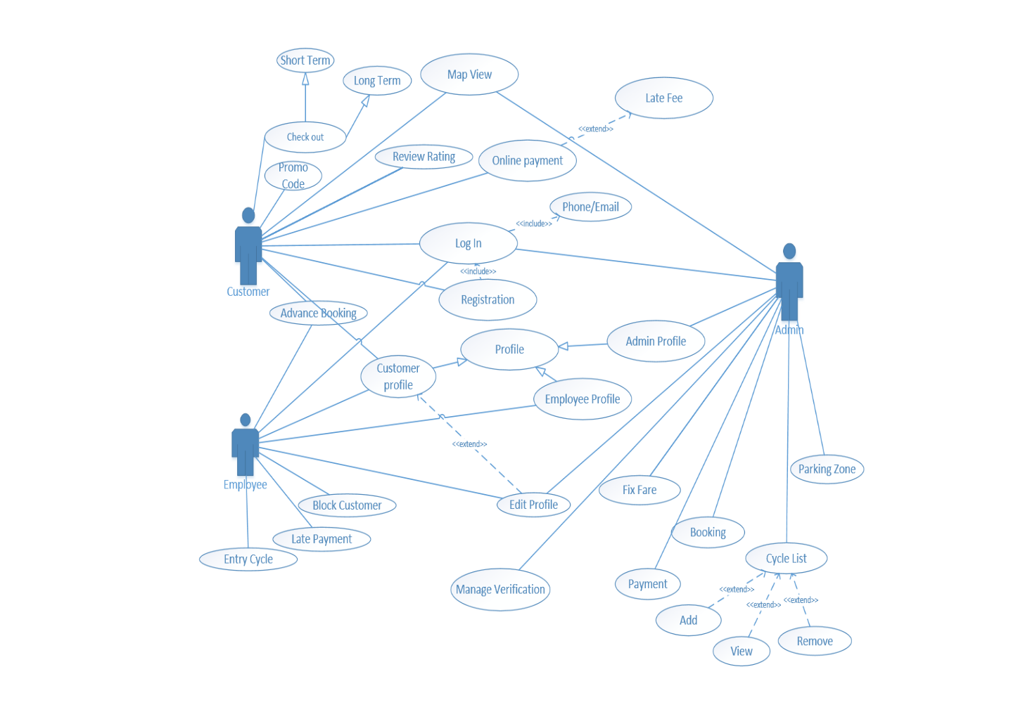

**Fig-1: Use Case Diagram**

**4.2.2 Activity Diagrams**

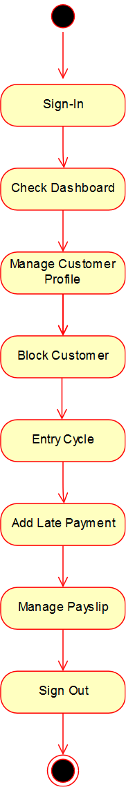

**Fig-2: Employee Activity Diagram**

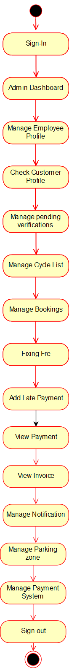

**Fig-3: Admin activity**

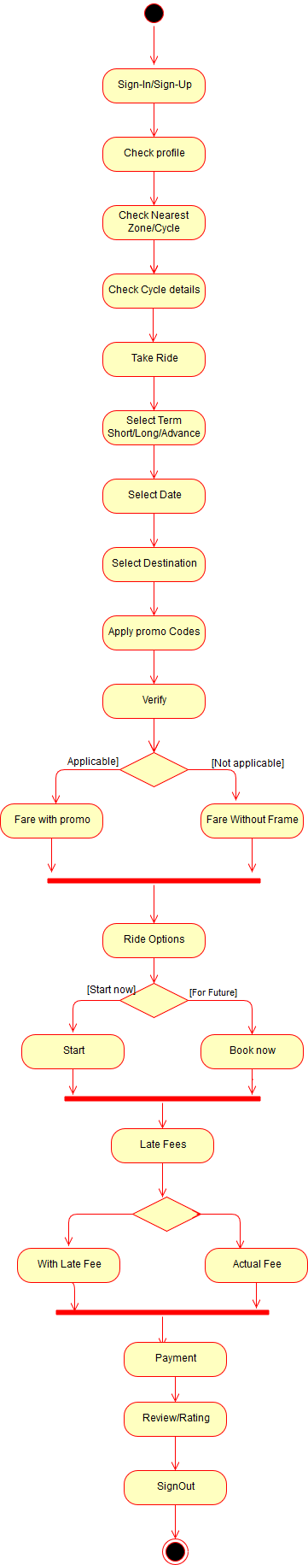

**Fig-5: User Activity**

**4.2.3 Entity Relation Diagram**

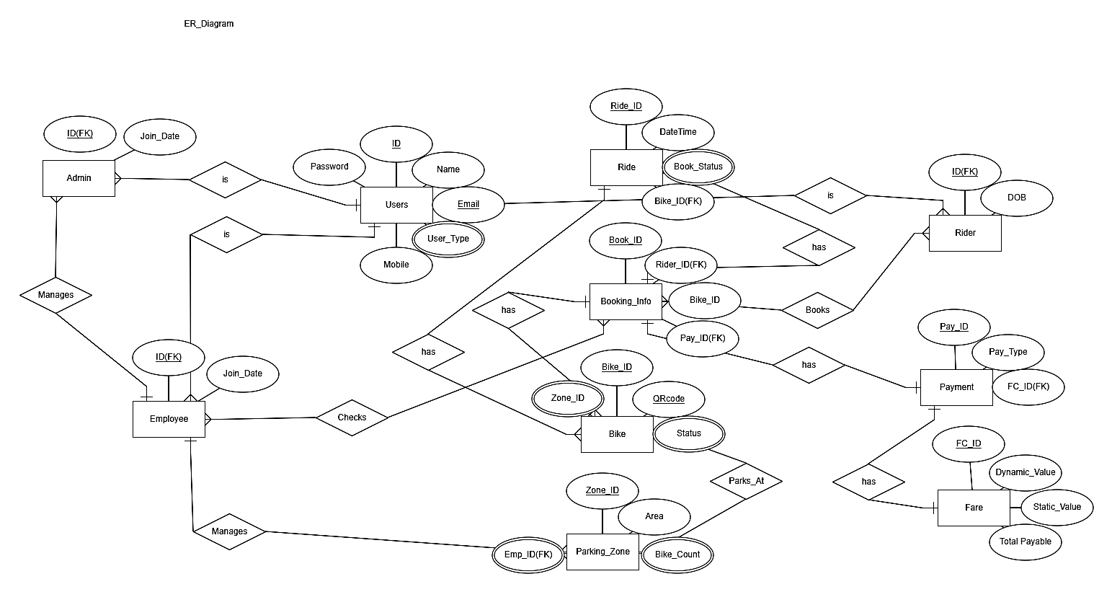

**Figure-6: ER diagram**

**Table-5:** Rider

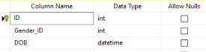

**Table-6:** Employees

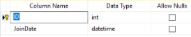

**Table-7:** Users

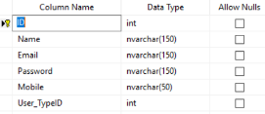

**Table-8:** Admin

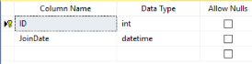

**Table-9:** Bike-Details

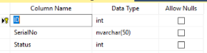

**Table 10: Book-Details**

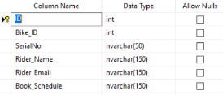

### 4.3 User Interface Design

Followings are images of some of our interfaces for this application:

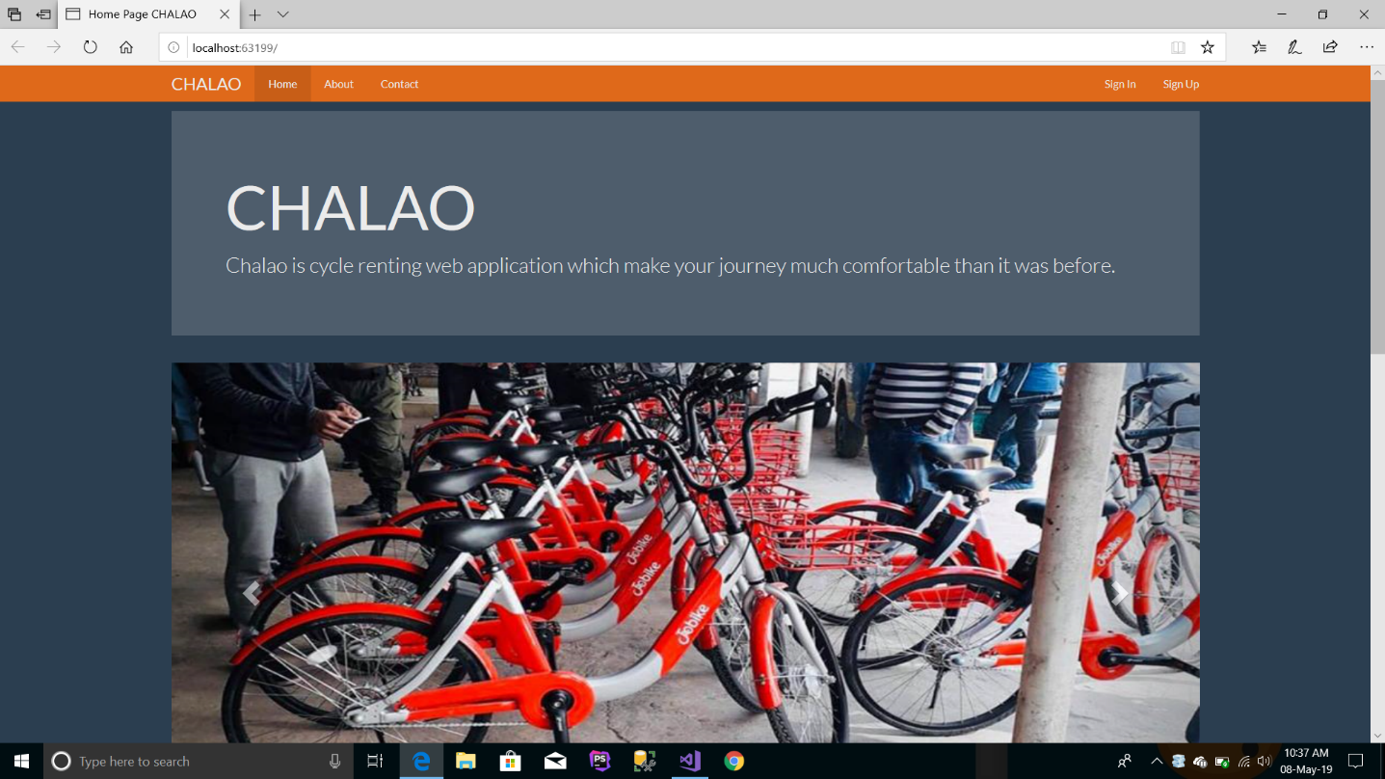

**Figure-7: Home page**

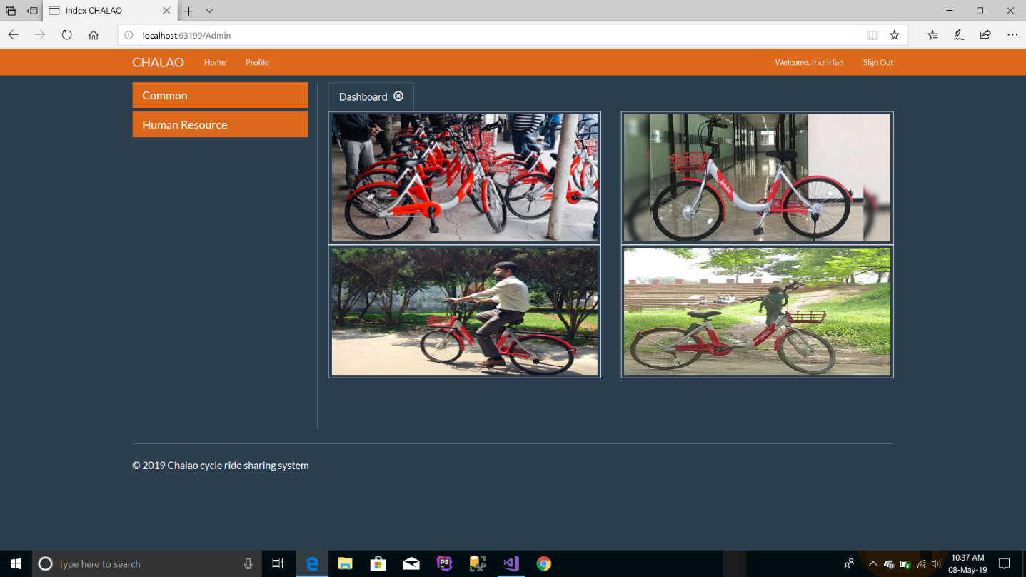

**Figure-8: Admin Panel**

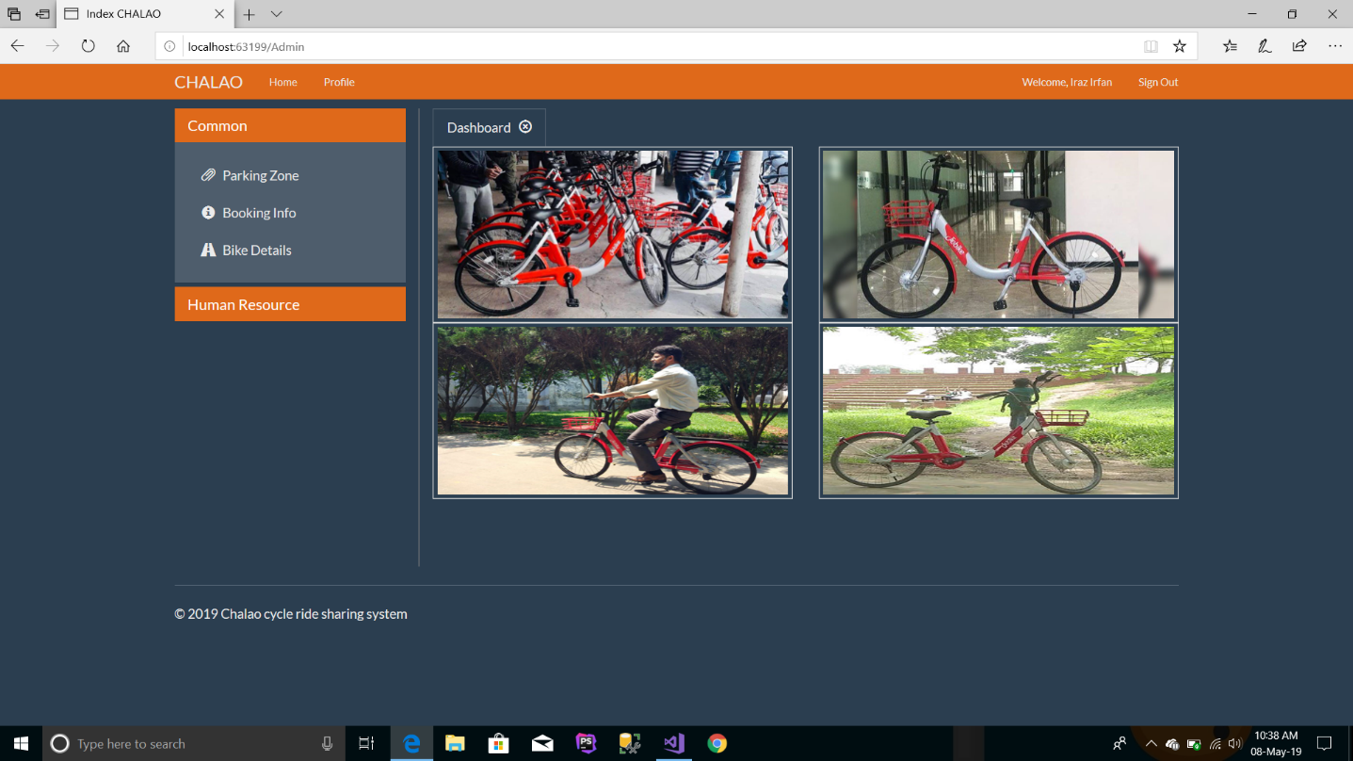

**Figure-9: Human Resource**

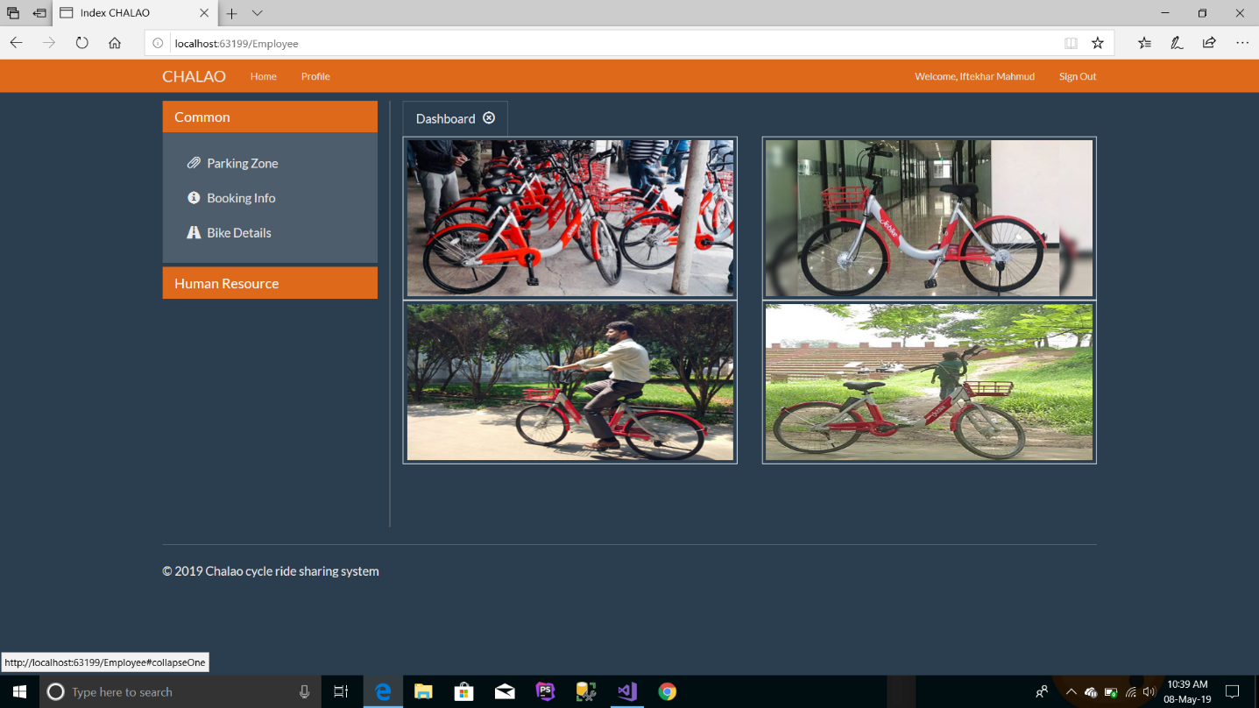

**Figure-10: Employee Panel**

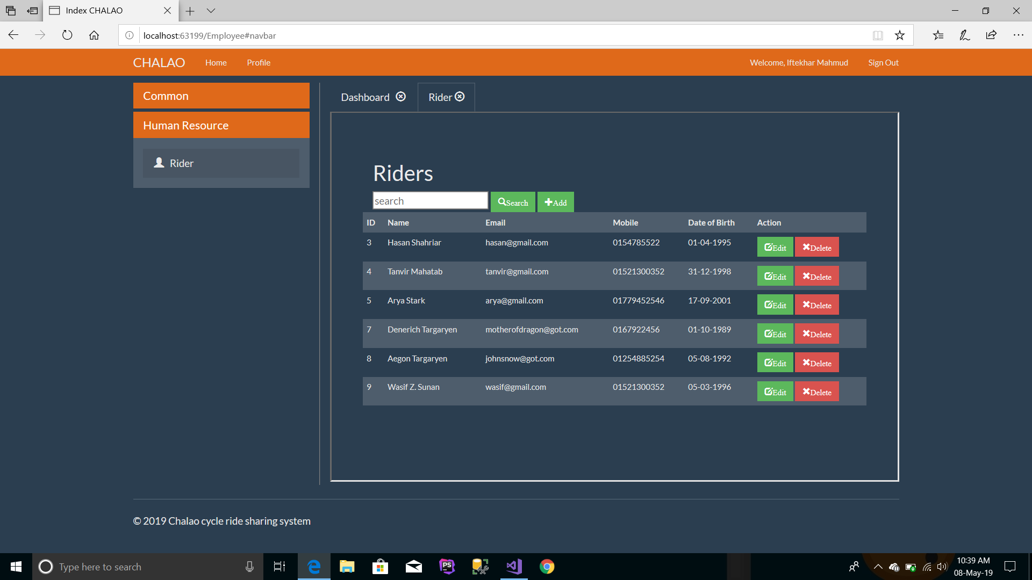

**Figure-11: Information Update Panel**

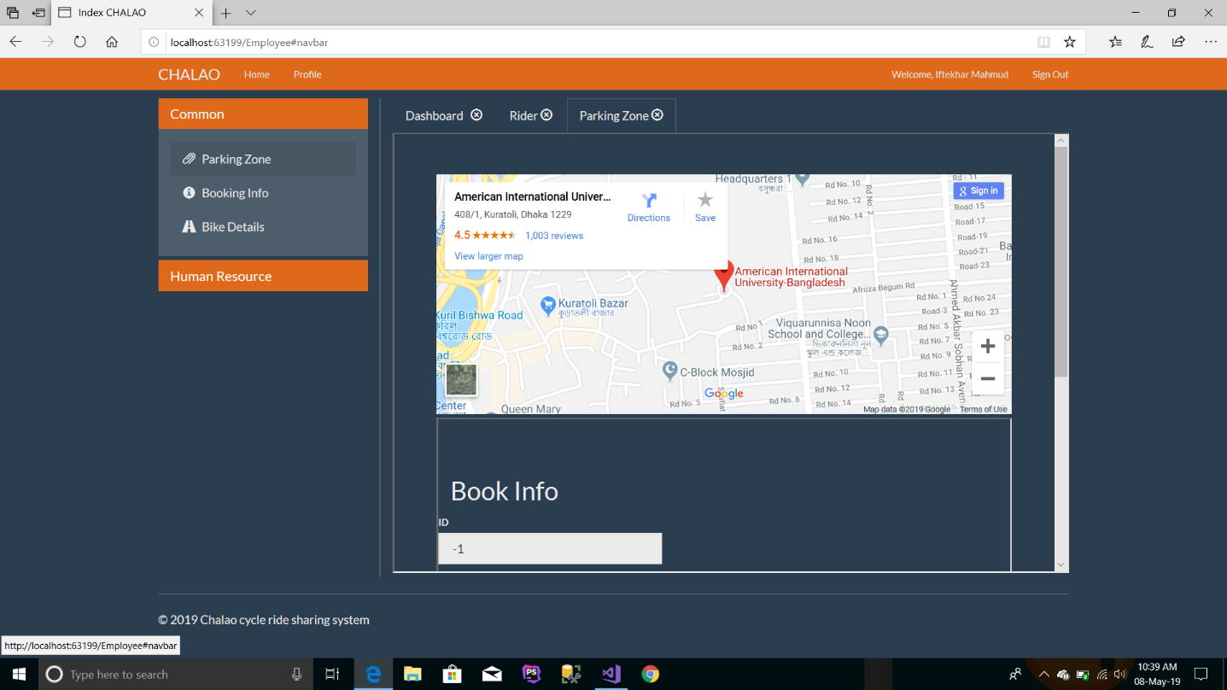

**Figure-12: Map View**

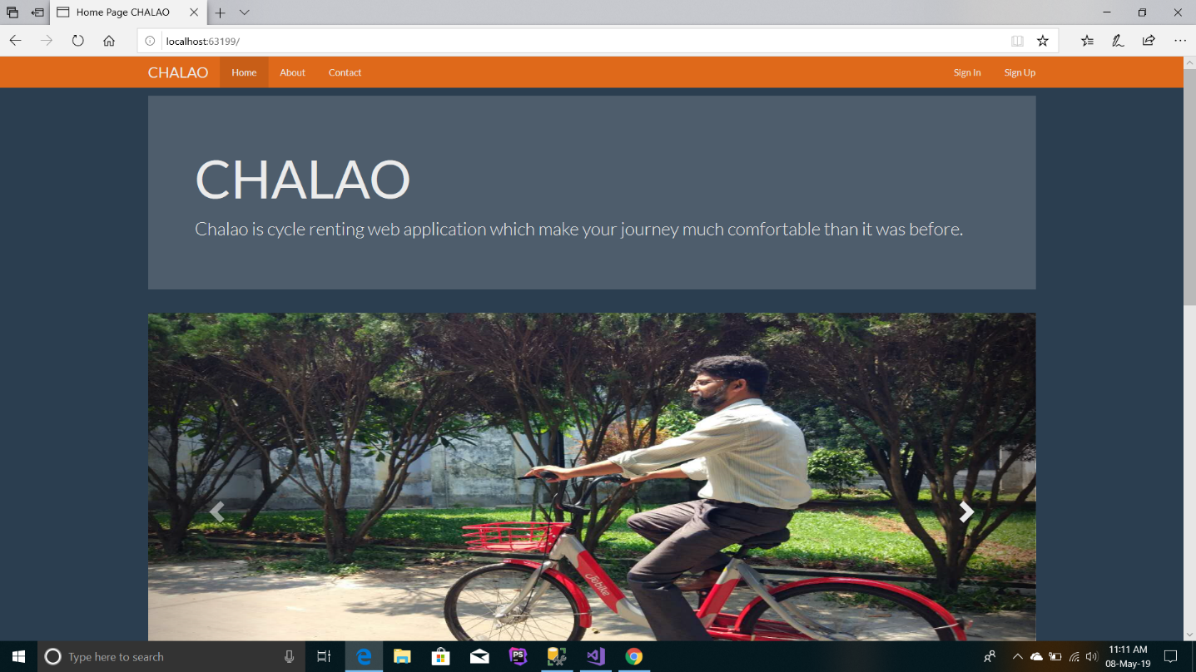

**Figure-13: Home Page**

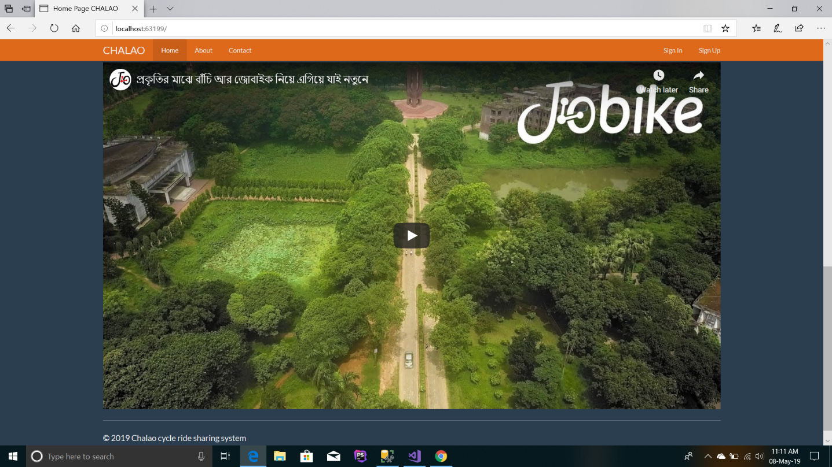

**Figure-13: Documentary Video**

|  |
| --- |
|  |
| **CHAPTER 5** |
|  |
| **FEATURE IMPLEMENTATIONS** |
|  |

#### Sign Up

**Required for:** Unregistered user

**Description**: A user need to sign up in the software to get all the facilities. So the user must give user name, email and password to create account.

**Priority**: High

**Functional Requirements:** System shall create a new account.

#### Login

**Required for:** admin, employee, user

**Description:** Given that a user has registered, then the user should be able to log in to the application. The log-in information will be stored and in the future the user should be logged in automatically.

**Priority:** High

**Functional Requirements:** System shall allow the user to use the account.

#### User profile

**Required for:** user, employee

**Description:** User shall be able to see his own profile and shall be able to update his profile. And employee shall be able to update user profile.

**Priority:** High

**Functional Requirements:** System shall store all the important user data in order to give information to the profile.

#### Map view integration

**Required for:** admin, user

**Description:** A user should be able to check nearest zone or check nearest cycle. Admin shall be able to manage the map, location and track all the cycles.

**Priority:** High

**Functional requirement:** System shall be able to find locations via map.

#### Checkout

**Required for:** user

**Description:** User shall be able to select short term ride or long-time ride on a system.

**Priority:** Medium

**Functional Requirements**: System shall be able to checkout for short term or long term.

#### 5.6 Feedback

**Required for:** user

**Description:** User shall be able to review and rate the system.

**Priority:** Medium

**Functional Requirements:** System shall show reviews of users.

#### 5.7 Advance Booking

**Required for:** user

**Description:** User shall be able to book a cycle in advance.

**Priority:** Medium

**Functional Requirements:** System shall provide advance booking.

#### 5.8 Apply Promo Code

**Required for:** user

**Description:** User shall be able to apply for promo code.

**Priority:** Medium

**Functional Requirements:** Promo code will be provided by the system.

#### 5.9 Payment

**Required for:** user

**Description:** User shall be able to see his fare after completing his ride.

**Priority:** Medium

**Functional Requirements:** System should calculate fare.

**5.10 Late fee**

**Required for:** user

**Description:** User have to pay late fee if delay to reach the destination.

**Priority:** Medium

**Functional Requirements:** System should calculate late fee

#### 5.11 User dashboard

**Required for:** user

**Description:** User shall be able to see the dashboard on which every trip history will be recorded.

**Priority:** Medium

**Functional Requirements:** System should store all trip history.

#### 5.12 Block customer

**Required for**: employee

**Description:** Employee shall be able to block any user.

**Priority:** Medium

**Functional Requirements:** System should remove any data.

#### 5.13 Entry cycle

**Required for:** employee

**Description:** Employee shall be able to entry new cycle on that zone.

**Priority:** Medium

**Functional Requirements:** System should be able to entry cycle.

#### 5.14 Add late payment

**Required for**: employee

**Description:** Employee shall be able to add late payment on user if user delays to reach the destination**.**

**Priority:** Medium

**Functional Requirements**: System should be able to add late payment.

#### 5.15 View salary

**Required for:** employee

**Description:** Employee shall be able to add late payment on user if user delays to reach the destination**.**

**Priority:** Medium

**Functional Requirements:** System should be able to add late payment.

#### 5.16 Employee Dashboard

**Required for:** employee, admin

**Description:** Employee shall be able to see the dashboard on which every trip history will be recorded.

**Priority:** Medium

**Functional Requirements:** System should be able to store all data.

#### 5.17 Employee Dashboard

**Required for:** employee, admin

**Description:** Employee shall be able to see the dashboard on which every trip history will be recorded. Admin shall be able to see employee dashboard.

**Priority:** Medium

**Functional Requirements:** System should be able to store all data.

#### 5.18 Manage Employee Profile

**Required for:** admin

**Description:** Admin shall be able to add employee, delete employee.

**Priority:** Medium

**Functional Requirements:** System should be able to add, delete from database.

#### 5.19 Manage pending verifications

**Required for:** admin

**Description:** Admin shall be able to manage pending requests for booking a cycle.

**Priority:** Medium

**Functional Requirements:** System should be able to manage verifications.

#### 5.20 Manage Cycle list

**Required for:** admin

**Description:** Admin shall be able to add or remove cycle from any zone.

**Priority:** Medium

**Functional Requirements:** System should be able to add or delete.

#### 5.21 Fixing Fare

**Required for:** admin

**Description:** Admin shall be able to fix fare. In addition, admin shall be able to offer discount.

**Priority:** Medium

**Functional Requirements:** System should be able to fix the fare.

#### 5.22 View Payment

**Required for:** admin

**Description:** Admin shall be able to view payments of every user and customer.

**Priority:** Medium

**Functional Requirements:** System should be able to show payment.

#### 5.23 View Invoice

**Required for:** admin

**Description:** Admin can see invoice**.**

**Priority:** Medium

**Functional Requirements:** System should be able to show invoice

#### 5.24 Manage Parking Zone

**Required for:** admin

**Description:** Admin can choose parking zone.

**Priority:** Medium

**Functional Requirements:** System should be able to show invoice

|  |
| --- |
|  |
| **CHAPTER 6** |
|  |
| **SOFTWARE TESTING PLAN** |
|  |

Project name is CHALAO and works on Android application. We can use three types of testing. They are:

* + - System testing
    - Regression testing
    - User Acceptance testing.

### System Testing

System testing is the testing of a complete and fully integrated software product. System tests the overall system operations as a whole, typically from a customer’s perspective. System testing presumes that all components have been previously, successfully, integrated. System testing is done after integration testing is complete. System testing main focus is to verify that the customer requirements are fulfilled. System testing should test functional and non-functional requirements of the software. System testing is black-box testing and often done by independent testers.

**6.2** **Regression Testing**

Regression tests determine that the system remains stable as it cycles through the integration of other subsystems and through maintenance tasks. Testing that is performed after making a functional improvement or repair to the program. Its purpose is to determine if the change has regressed other aspects of the program. In this category, new tests are not designed; instead, test cases are selected from the existing pool and executed.

**6.3 Acceptance Testing**

Acceptance testing is Formal testing for product evaluation. Formal testing conducted to determine whether a system satisfies its acceptance criteria. Performed by customers/end users (preferably). Verifies functionality and usability of the software. Conducted prior to software being released to live operation. At this level of testing, the software should be in a sufficiently defect-free state to permit the emphasis to change. Acceptance testing is usually the last step before the user/customer takes the possession of the software

|  |
| --- |
|  |
| **CHAPTER 7** |
|  |
| **CONCLUSION** |
|  |

* 1. **Future Work**

The project is still at its basic stage with the additional multi-tenant advantage. There are more things that are already proposed while designing the database but still not released in first version. In future, we are expecting to work on Map and Food order system to our application along with solving some obvious bugs.

### Contribution to the Society

|  |
| --- |
|  |
| **CHAPTER 8** |
|  |
| **REFERENCES** |
|  |

1. <https://www.uber.com/bn/en/ride/>
2. <https://pathao.com/bn/>
3. <https://www.yulu.bike/>
4. <https://pedl.cepr.org/content/about-pedl>
5. <https://www.obhai.com/>
6. <https://mobike.com/global/>
7. <https://www.jo.bike/>